- The block above is pulled a distance of 2.0 m. How much work is done by the force?
  - 2.3 J
  - 4.5 J
  - 9.0 J
  - 18 J
  - 36 J

- As a tossed ball rises, its kinetic energy ____________ while its total energy ______________. Ignore air resistance.
  - increases, decreases
  - decreases, increases
  - increases, remains the same
  - decreases, remains the same
  - remains the same, remains the same

Questions 3 – 8
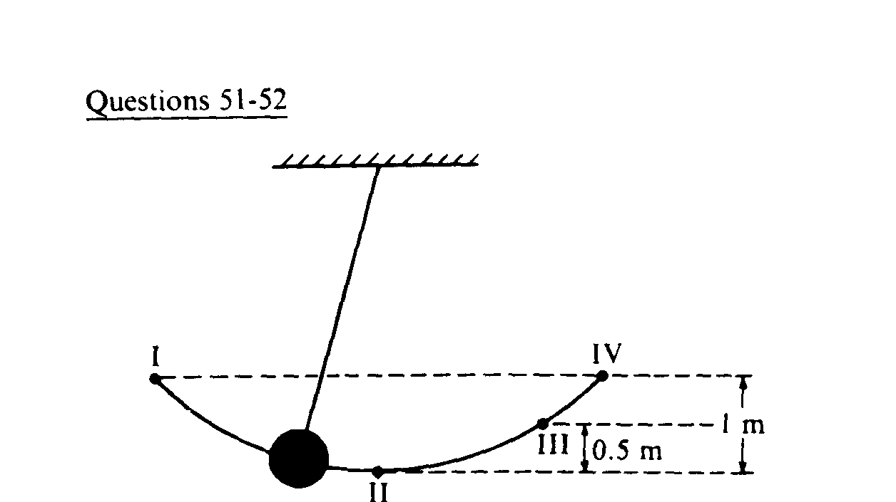

A pendulum swings freely back and forth in an arc from point I to point IV, as shown above. Point II is the lowest point in the path, point III is located 0.5 m above II, and point IV is 1 m above point II. Air resistance is negligible. The mass of the pendulum ball is 2 kg.

- At which position does the pendulum have the maximum kinetic energy?
  - I
  - II
  - III
  - IV
  - At all points

- How much potential energy does the ball have at position I?
  - 1 J
  - 5 J
  - 10 J
  - 20 J
  - 40 J

- What is the speed of the pendulum at position II?
  - 0 m/s
  - 3.2 m/s
  - 4.5 m/s
  - 10 m/s
  - 14 m/s

- What is the speed of the pendulum at position III?
  - 0 m/s
  - 3.2 m/s
  - 4.5 m/s
  - 10 m/s
  - 14 m/s

- At what position does the pendulum’s kinetic energy equal its potential energy?
  - I
  - II
  - III
  - All points
  - No points

- A moving object of mass m and speed v has a kinetic energy given by K. What will be its new kinetic energy if its mass is tripled and its speed is doubled?
  - 2K
  - 3K
  - 6K
  - 12K
  - 18K

- An 82-kg man runs up a flight of stairs in 4.0 s. His net upward displacement is 6.0m. What is his average power output?
  - 1000 W
  - 1230 W
  - 1460 W
  - 1600 W
  - 2000 W
- The impulse experienced by an object is equal to its change in _____________.
  - velocity
  - kinetic energy
  - momentum
  - none of the above

- An egg dropped on the road usually breaks, while one dropped on the grass usually doesn’t break. This is because for the egg dropped on the grass
  - the change in momentum is greater.
  - the change in momentum is less.
  - the time interval for stopping is greater.
  - the time interval for stopping is less.

- Compared to a car moving at 30 miles per hour, the same car moving at 90 miles per hour has ________.
  - the same momentum
  - three times the momentum
  - four times as much momentum
  - nine times the momentum

Questions 13-16
A bug and the windshield of a fast-moving car collide. Use the following answers for questions 13 – 16:
      - greater than
      - less than
      - equal to

- The force of impact on the bug is ________ the force of impact on the car.

- The impulse on the bug is ________ the impulse on the car.

- The change of speed of the bug is ________ the change in speed of the car.

- The change in momentum of the bug is ________ the change in momentum of the car.

- A cannon recoils from launching a cannonball. The speed of the cannon’s recoil is small because the ________.
  - force acting on the cannon is smaller than the force acting on the cannonball.
  - the impulse on the cannon is less than the impulse on the cannonball.
  - cannon has much more mass than the cannonball.
  - momentum of the cannon is less than that of the cannonball.

- A 20-kg cart has a momentum of 300 kgm/s east. What is the velocity of the cart?
  - 6000 kgm/s east
  - 6000 kgm/s west
  - 15 kgm/s east
  - 15 kgm/s west

- Determine the period of a pendulum with a length of 0.5 m on earth.
  - 0.8 s
  - 1.1 s
  - 1.4 s
  - 1.9 s

- The period of a pendulum depends on ______.
  - Amplitude and length
  - Mass and amplitude
  - Gravity and mass
  - Gravity and length

- A bucket of water is whirled in a vertical circle at constant speed. Why doesn’t the water spill out of the bucket when it is at the top of its circular path?
  - Because there is a centrifugal force acting on the water.
  - Because there is an equal and opposite force pulling the water up.
  - Because the water has too much mass to fall.
  - Because the water is traveling fast enough at the top to not fall out.

Questions 22 and 23
The graph below shows the position vs. time of an object undergoing simple harmonic motion.

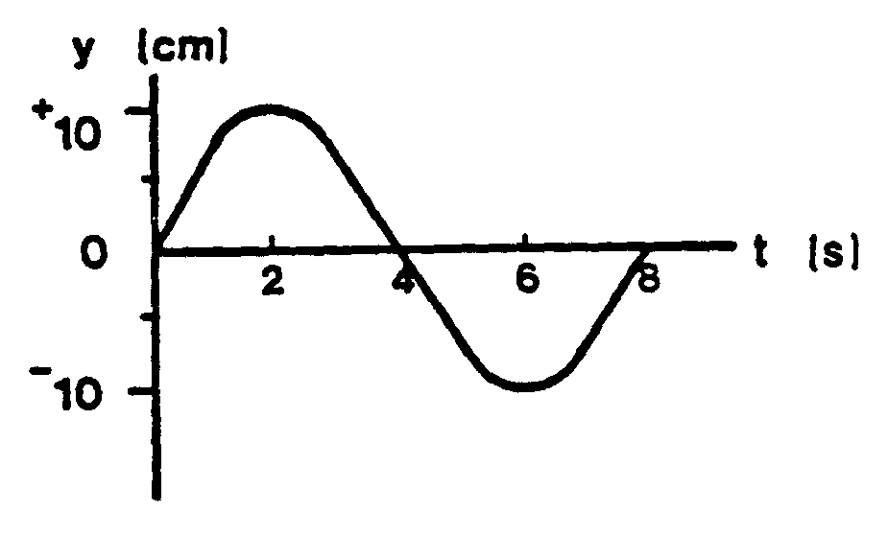
- What is the object’s position as a function of time?
  - x = 10 cos (πt/8)
  - x = 10 sin (πt/4)
  - x = 5 sin (πt/8)
  - x = 5 cos (πt/4)

- At what time does the object have its maximum speed?
  - 2 s
  - 4 s
  - 5 s
  - 6 s

- A force of 80 N is required to stretch a spring a distance of 0.5 m. What is the spring constant of the spring?
  - 40 N/m
  - 80 N/m
  - 160 N/m
  - 320 N/m

- How much energy is stored in a spring (k = 200 N/m) when it is stretched a distance of 0.9 m?
  - 81 J
  - 90 J
  - 180 J
  - 222 J

- What provides the centripetal force for the circular motion of the moon?
  - Friction
  - Tension
  - Normal force
  - Gravity

- A 1500-kg car travels around a circular track (radius = 30 m) at 22 m/s. What is the centripetal force acting on the car?
  - 16.1 N
  - 24, 200 N
  - 46, 840 N
  - 532,400 N

- A runner moves at 6.2 m/s around a track of radius 12 m. Find the runner’s acceleration.
  - 3.2 m/s²
  - 4.3 m/s²
  - 7.6 m/s²
  - 9. 2 m/s²

- Which diagram below correctly shows the path a ball tied to a string would take if the string were to break at the instant shown?

Questions 30-35
A 4-Ω bulb, 6-Ω bulb, and a 12-Ω bulb are connected in series to a 9-V battery.

- What is the equivalent resistance of the circuit?
  - 2 Ω
  - 10 Ω
  - 22 Ω
  - 26 Ω

- How much current leaves the battery?
  - .53 A
  - .41 A
  - 2.3 A
  - 4.5 A

- What power does the battery deliver to the circuit?
  - 3.7 W
  - 11.6 W
  - 40.5 W
  - 63.2 W

- What is the same for each light bulb in this circuit?
  - current
  - voltage
  - power
  - resistance

- If the 4-Ω light bulb is unscrewed, the current through the 6-Ω bulb _____.
  - increases
  - decreases
  - remains the same

- If another resister is added in series, the current that leaves the battery _____.
  - increases
  - decreases
  - remains the same

Questions 36-41
A 4-Ω bulb, 6-Ω bulb, and a 12-Ω bulb are connected in parallel to a 9-V battery.
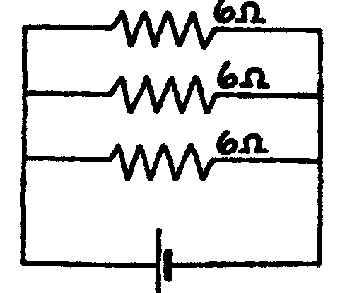
- What is the equivalent resistance of the circuit?
  - 2 Ω
  - 10 Ω
  - 22 Ω
  - 26 Ω

- How much current leaves the battery?
  - .53 A
  - .41 A
  - 2.3 A
  - 4.5 A

- What power does the battery deliver to the circuit?
  - 3.7 W
  - 11.6 W
  - 40.5 W
  - 63.2 W

- What is the same for each light bulb in this circuit?
  - current
  - voltage
  - power
  - resistance

- If the 4-Ω light bulb is unscrewed, the current through the 6-Ω bulb _____.
  - increases
  - decreases
  - remains the same

- Adding another resistor in parallel __________ the amount of current that leaves the battery.
  - increases
  - decreases
  - does not affect
- Two charged objects are separated by a distance d. If the separation is doubled, the amount of electrostatic force __.
  - Is cut in half
  - Is doubled
  - Is quadrupled
  - Is reduced by 1/4

- A +7 μC charge and a –2μC are separated by 0.3 m. What is the force between them?
  - 0.42 N attractive
  - 0.42 N repulsive
  - 1.4 N attractive
  - 1.4 N repulsive

- Which of the following will create a magnetic field?
  - Moving neutrons
  - Moving electrons
  - Stationary protons
  - Stationary neutrons

- How can one make an electromagnet?
  - Connect two batteries together.
  - Wrap a wire around an iron core and send current through the wire.
  - Stroke a battery with a permanent magnet.
  - Heat up a permanent magnet.

- Which of the following statements is FALSE?
  - Magnetic force between two magnets increases as two magnets get closer together.
  - When a bar magnet is broken in half, two smaller magnets result.
  - It is possible to have a north pole without a south pole.
  - A current-carrying wire creates a magnetic field around it.

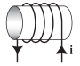
- A coil with a current is shown below. In the center of the coil, what direction does the magnetic field point?
  - Up
  - Down
  - Left
  - Right

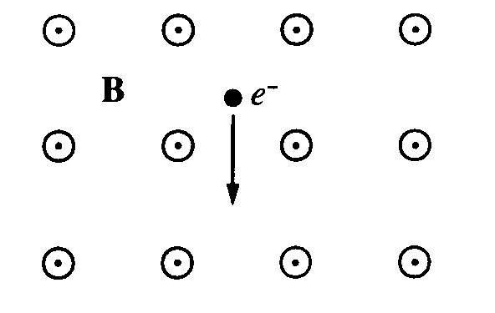
- An electron is in a uniform magnetic field B that is directed out of the plane of the page, as shown to the right. When the electron is moving down, the magnetic force on the particle is directed
  - toward the right
  - toward the left
  - into the page
  - out of the page

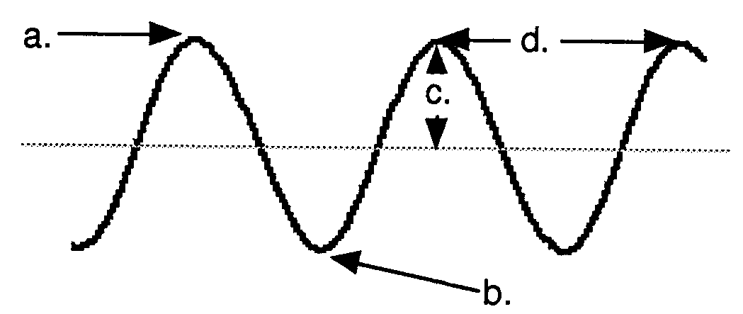
- The diagram above has arrows pointing to four characteristics of a wave. What is the correct order that they should be listed?
  - Trough, crest, λ, amplitude
  - Crest, trough, λ, amplitude
  - Trough, amplitude, λ, crest
  - Crest, trough, amplitude, λ

Questions 50 and 51
The periodic wave in the diagram below has a frequency of 40 Hz.

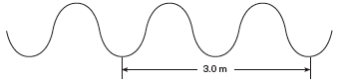
- What is the speed of the wave?
  - 13 m/s
  - 27 m/s
  - 60 m/s
  - 240 m/s

- What is the period of the wave?
  - 0.33 s
  - 0.025 s
  - 40 s
  - 0.15 s

- The figure below shows two wave pulses that are approaching each other.

Which of the following best shows the shape of the resultant pulse when the centers of the pulses, points P and Q, coincide?
a.
b. 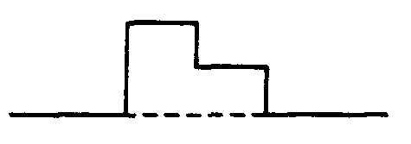
c.
d.

Question 53
The diagram below shows waves A, B, C, and D traveling in the same medium.

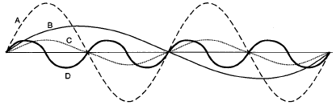
- Waves ____________ have the same wavelength and wave ____ has the greatest frequency.
  - A and B …. B
  - A and C …. D
  - B and D …. D
  - C and D …. B

- Sound waves are _____ waves.
  - transverse
  - longitudinal
  - electromagnetic
  - seismic

- A sound’s pitch depends on its
  - amplitude
  - wavelength
  - frequency
  - speed

- A person runs at 9 m/s towards a stationary police car whose siren has a frequency of 500 Hz. What frequency does the person detect? (The speed of sound is 345 m/s)
  - 491 Hz
  - 500 Hz
  - 513 Hz
  - 522 Hz

- A 1.6-m long string vibrates in the fourth harmonic (5 nodes, 4 antinodes). What is the wavelength of the sound wave?
  - 0.4 m
  - 0.8 m
  - 1.2 m
  - 1.6 m

- A boat surveys the ocean bottom with ultrasonic sound that travels at 1500 m/s in seawater. How deep is the water if the time delay of the echo from the ocean floor is 4 seconds?
  - 1500 m
  - 3000 m
  - 4500 m
  - 6000 m

- What is the beat frequency observed when a 256 Hz and a 259 Hz tuning fork are sounded together?
  - 3 Hz
  - 6 Hz
  - 257.5 Hz
  - 515 Hz

- As temperature increases, the speed of sound in air ______.
  - increases
  - decreases
  - remains the same

- The bending of light when it enters a new medium at an angle is known as ______.
  - reflection
  - refraction
  - diffraction
  - dispersion
- Light travels from air to glass. If the angle of incidence is 63°, what is the angle of refraction? (n_{glass} = 1.6)
  - 25.4°
  - 30.2°
  - 33.8°
  - 37.1°

- Which is not part of the electromagnetic spectrum?
  - visible light waves
  - radio waves
  - sound waves
  - X-rays

- If the speed of light in a medium is 1.5 x 10⁸ m/s, what is the index of refraction of the medium?
  - 0.5
  - 0.67
  - 1.5
  - 2.0

- What is the critical angle between water (n = 1.33) and diamond (n = 2.42)?
  - 33°
  - 47°
  - 53°
  - 57°

- In a vacuum, microwaves and X-rays have the same _______.
  - speed
  - wavelength
  - frequency
  - period

- Polarization is an exclusive property of _____ waves. In order to completely block light, ____ polarizing filters are required.
  - Transverse … 2
  - Longitudinal … 10
  - Transverse … 5
  - Longitudinal … 3

- What type of mirror is only capable of producing small, upright images?
  - Concave
  - Convex
  - Plane
  - Two-way

Questions 69 and 70
An object is placed 30 cm away from a converging lens of focal length 10 cm.

- Where is the image located?
  - 15 cm behind the lens.
  - 7.5 cm behind the lens.
  - 30 cm behind the lens.
  - 45 cm behind the lens.

- Which of the following describes the image produced?
  - Real, inverted, larger
  - Virtual, upright, smaller
  - Real, upright, larger
  - Real, inverted, smaller

