Activity 4.2 Model Creation

Introduction
To effectively use a CAD program to create 3D models of a part, a designer must be familiar with the basic strategies of additive and subtractive modeling methods. This activity will help you understand the sketching tools and extrusion features that are common to most CAD programs, plan an efficient method of simple model creation, and gain experience creating simple 3D models.

Equipment
- Computer with 3D CAD solid modeling program

Procedure
Follow the instructions to create 3D solid models of each of the following objects using the specified method(s) and respond to the prompts.

1. | 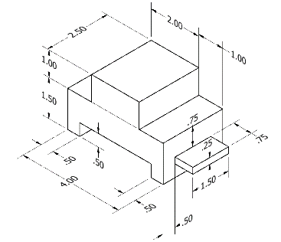
 | All dimensions are in inches.

2. | 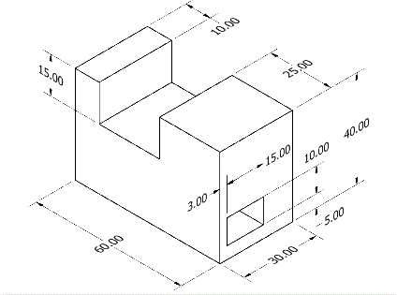
 | All dimensions are in mm.

3. | 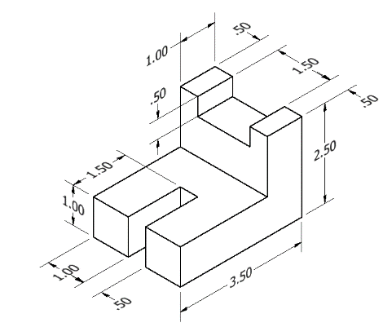
 | All dimensions are in inches.

4. | 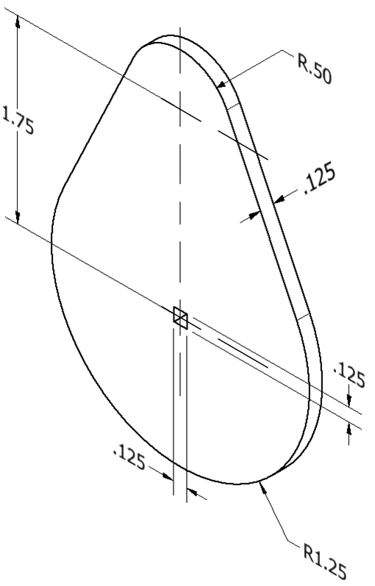
 | All dimensions are in inches.

