BULL’S EYE II

In this activity you will determine the landing spot of a pendulum ball using conservation of energy and projectile motion equations.

EQUIPMENT: pendulum apparatus, C clamp, meter stick, pendulum bob, bulls-eye, razor blade, string.

PROCEDURE:
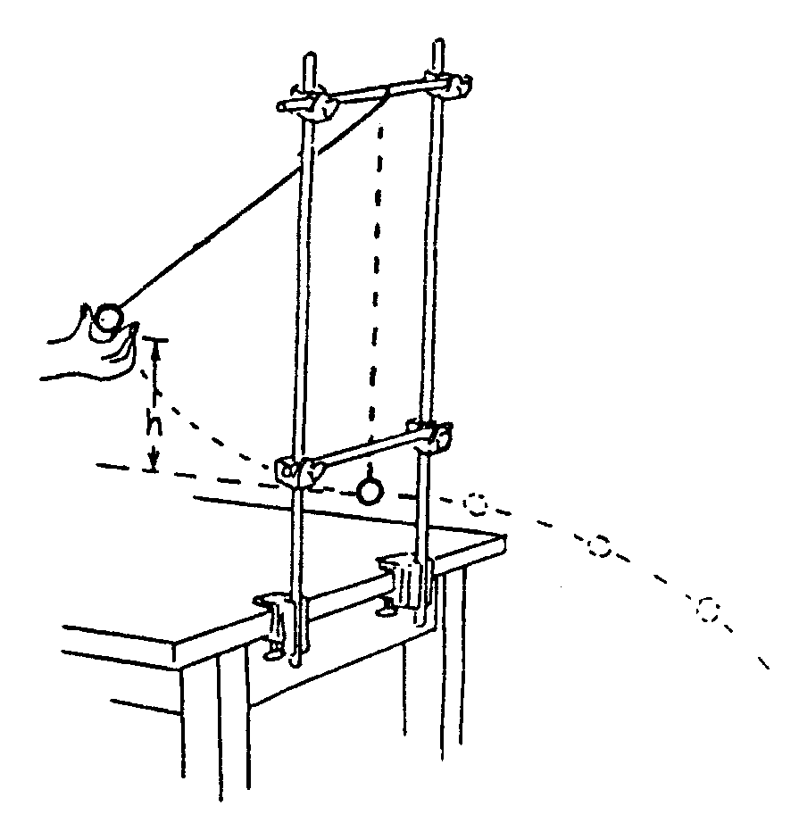
- Assemble the apparatus as shown in the diagram to the right.
- Determine the mass of pendulum bob:
Mass = ___ kg

- Raise the pendulum to a desired vertical height. Measure the height of this position above the table top.
Initial Height = ____m

- Measure the height of the pendulum bob when it is at the bottom of the swing. Record this height below.

Final Height = ____m

- Use the table below to determine how fast the bob will be traveling at the lowest part of its swing if it is released from ret. Note: The mass of the bob is _____ kg.

h (m) | v (m/s) | KE (J) | PE (J) | TE (J)

- When the bob reaches the bottom of its swing, all of the potential energy it gained when it was pulled back will be converted to _____________ energy.

- Draw an arrow in the space below to show the direction the ball will be moving when it encounters the razor blade.
- The ball will now be acting as a projectile launched from a cliff. What type of projectile motion problem is this?

- Set up a Projectile Motion Table (X – Y chart) to solve how far away the target should be placed. To do this you must first determine the amount of time that the ball will be in free fall. Show your work below.

- Place the bulls-eye on the floor where you think the ball will hit. Tape your target down.

- Notify your teacher that you are ready to proceed.
- Release the pendulum ball from the pre-measured height.

INTERPRETATIONS:

- What if you had used a ball with twice the mass instead? Complete a new table, keeping the initial and final heights the same.

h (m) | v (m/s) | KE (J) | PE (J) | TE (J)

How are the quantities below affected?

- Initial potential energy ____________

- Total energy _____________

- Final potential energy ____________

- Kinetic energy at bottom if swing ______________

- Velocity at bottom of swing _______________

- Time in air ______________

- Horizontal distance traveled ______________

- What conclusion can you make about the mass of the bob and the landing spot based on question 1?

- State what effect the following errors will have on the landing spot of the projectile. Will it land before the bull’s eye or beyond?

- The bob is accidentally pulled back to a height of 30 cm instead of 31 cm when it is released.

- The bob is accidentally given a push when it is released.

- The mass of the bob is 0.12 kg instead of 0.10 kg.

- A bob is pulled back so that its vertical height above a table has been increased by 30 cm. It is released and travels to the razor where it is cut. It is cut at a vertical height of 10 cm above the table. Where ON THE TABLE should the target be placed for a bull’s eye hit?

