Problem Set 1

- Billy carries a 5.2-kg package up a flight of stairs. The vertical height of the stairs is 3.6 m.
  - What is the weight of the package?
  - How much work does Billy do on the package?
  - The work Billy does on the package is equal to the __________ of the package at the top of the stairs.

- Matilda needs to lift a 90-kg dresser into a moving van. The height of the moving van is 1.5 m above the ground.
  - What is the weight of the dresser?
  - How much work is required to lift the dresser straight into the van?
  - Rather than lifting the dresser straight up, Matilda decides to push it up a frictionless ramp that is 4.5 m long. This path will result in the same amount of ________ but the ________ will be __________.
  - How much force is needed to push the dresser up the ramp?
  - What is the mechanical advantage of the ramp?

- A 1500-kg car traveling at 30 m/s has the same kinetic energy as a 4500-kg truck.
  - What is the kinetic energy of the car?
  - What is the speed of the truck?

- A 90-kg boulder is at rest on top of a hill. The potential energy of the boulder is 23,800 J.
  - What is the height of the hill?
  - In order to have the same amount of energy, an equal-sized boulder on the ground would have to be moving at what speed?

Problem Set 2

- How much work is needed to lift a 25-kg object to a height of 15 m?

- How much force is applied to move an object 30 m if 700 J of work is done?

- How much potential energy does a 4-kg object have when sitting on a 3.4-m shelf?

- How much kinetic energy does a 2500-kg truck have when traveling at 28 m/s?

- At what height should a 1000-kg car be parked to have the same amount of energy as the truck in the previous problem?

- A 0.2-kg apple hangs from a 4.5-m high branch.
  - What is the apple’s total energy?
  - When it falls to a height of 2 m, how fast is it traveling?
  - What is the apple’s speed when it hits the ground?

Speed | Height | KE | PE | TE
0 m/s | 4.5 m

- A 50-kg cannonball is fired straight up from a height of 25 m at a speed of 20 m/s.
  - What is the total energy of the cannonball?
  - What is the maximum height of the cannonball?
  - What is the speed of the cannonball when it is 10 m above the ground?
  - What is the greatest speed the cannonball attains? When does this occur?

Speed | Height | KE | PE | TE
20 m/s | 25 m
Problem Set 3

- A 1000-kg roller coaster is pulled up a hill of 42 m and is released from rest at the top.
  - What is the total energy of the roller coaster?
  - What is the speed of the roller coaster at the bottom of the first hill?
  - How fast is the roller coaster traveling when it is at a height of 18 m?
  - What is the height of the roller coaster when its speed is 14 m/s?

Speed | Height | KE | PE | TE

- A 2-kg ball is tossed straight up off a cliff of 72 m with a speed of 34 m/s.
  - What is the total energy of the ball?
  - What is the kinetic energy of the ball at its highest point?
  - What is the maximum height reached by the ball?
  - What is the speed of the ball when it is at a height of 84 m?
  - What is the height of the ball when its speed is 17 m/s?
  - What is the speed of the ball the instant it lands on the ground below the cliff?

Speed | Height | KE | PE | TE

- Which answers will change in the above problem if the ball is thrown with the same speed at an angle of 30° above the horizontal? The ball is still thrown off a cliff of height 72 m. For any answers that change, determine the new values.

Speed | Height | KE | PE | TE

- Fill in the following blanks: A coconut that hangs from a palm tree has _____________ energy. The greater the height of the coconut, the greater its potential to do _____________ if released. As a coconut falls to the ground its _____________energy converts to ______________ energy but its ___________ energy remains the same. When the coconut is halfway to the ground, half of its energy is in the form of ___________ and the other half is in the form of kinetic. The moment the coconut strikes the ground, all of its energy is in the form of ______________. At this instant, the coconut has its ______________ speed.

Problem Set 4

- A large icicle of mass 9 kg hangs from a roof 11 m above the ground.
  - How much potential energy does it have?
  - If it breaks off, how much kinetic energy will it have as it strikes the ground?
  - What will be its final speed as it lands?

- A golfer misses a putt and throws his golf club straight up into the air in frustration. His putter has a mass of 7 kg and it leaves his hands at 10 m/s.
  - What is the kinetic energy of the putter as it leaves his hands?
  - What is the maximum height the putter reaches?
  - What is the speed of the putter when it is halfway to its maximum height?

- A girl sets a volley ball straight up in the air with an initial speed of 5 m/s.
  - How high above her hands does it go?
  - How fast is the ball moving when it is 0.4 m above her hands?

- A roller coaster starts from rest at the top of a frictionless track of height 18 m. The car travels to the bottom of the hill and continues up the next hill that is 10 m high.
  - How fast is the roller coaster traveling at the bottom of the first hill?
  - How fast is the roller coaster traveling at the top of the 10-m hill?

- A 60-kg skier leaves the end of a ski jump with a velocity of 25 m/s at an angle of 30° from the horizontal. The ski jump is 80 m above the ground.
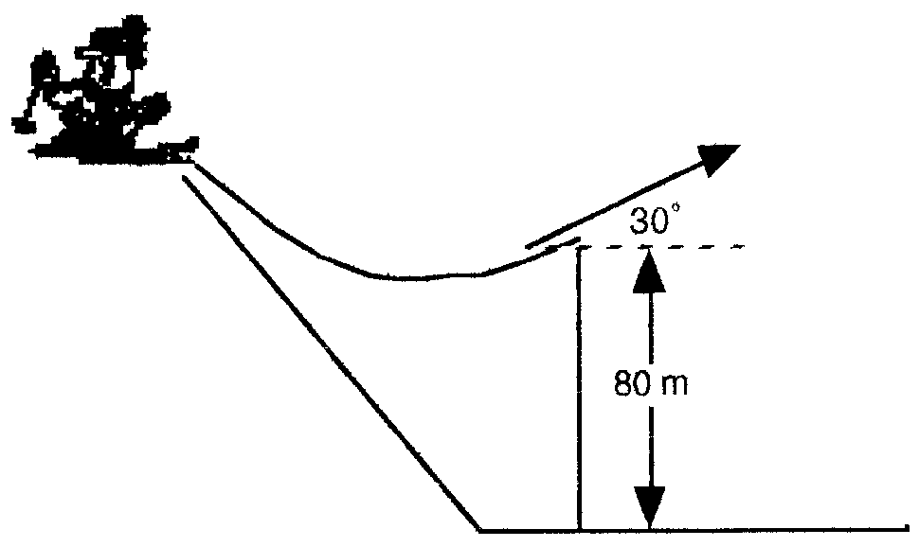
  - What is the skier’s total energy when he leaves the jump?
  - What is the kinetic energy of the skier when the skier reaches his highest point? (Be careful, it’s not zero!)
  - What is the maximum height reached by the skier?
  - What is the skier’s speed just as he lands on the ground below?

Problem Set 5

Conservation of Energy with Friction

- A 3 kg crate slides down a 2 m long ramp that makes an angle of 30° with the ground. The crate starts from rest at the top and experiences a constant frictional force of magnitude 5 N as it slides down. How fast is the crate going at the bottom of the ramp?

- Starting from rest, a 10 kg block slides 3 m down a frictionless ramp (inclined at 30° from the floor) to the bottom. The block then slides an additional 5 m along the floor before coming to a stop. Determine (a) the speed of the block at the bottom of the ramp, (b) the force of friction between the block and the floor, and (c) the coefficient of kinetic friction between the block and floor. *Remember: friction = μ x normal

- A 2100 kg car starts from rest at the top of a 5 m long driveway that is sloped at 20° with the horizontal. If an average friction force of 4000 N impedes the motion, find the speed of the car at the bottom of the driveway.

- A 70 kg diver steps off a 10 m tower and drops from rest straight down into the water. She comes to rest 5.0 m below the surface of the water.
  - How fast is she moving the moment she enters the water?
  - How much heat is generated as the water stops the diver?
  - What is the average resistive force exerted on her by the water?

