Introduction to Magnetism

1. List one way that magnets are like electric charges and one way they are different from electric charges.
a.

b.
2. Regions that produce magnetic forces are called magnetic _____________________.

3. Is the following sentence true or false? Every magnet, regardless of its shape, has both a north pole and a south pole.

4. Write attract or repel to describe the effect of bringing the poles listed below together.
______________________ a. the north pole of a bar magnet near the north pole of another bar magnet.
______________________ b. the north pole of a bar magnet near the south pole of another bar magnet.
______________________ c. the south pole of a bar magnet near the south pole of another magnet.

5. Define magnetic field.

6. Describe what happens if you place a magnetic compass near a bar magnet.

7. Describe a simple electromagnet.

8. Is the following sentence true or false? Electricity and magnetism are related.

9. Moving electric charges create ______________________ _____________________.

10. A metal bar magnet has a magnetic field in the region of space around it. The magnetic field is due to:
A magnetic monopoles embedded in the metal.
B a hidden voltage source in the metal.
C the motion of charged particles in the metal.
D an electric current that runs along the length of the magnet.

11. A wire carries a current of 15 mA. Calculate:

A) The magnetic field 2 cm from the center of the wire.

B) Repeat for 6 cm from the center of the wire.

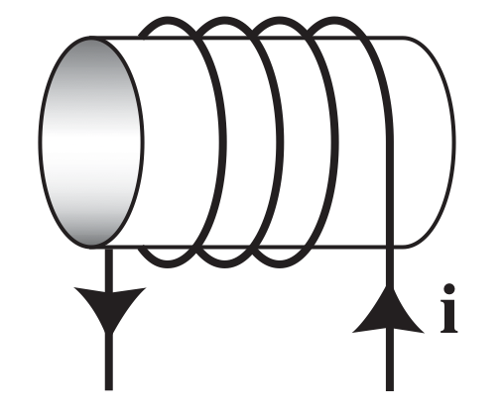
12 . A coil with a current is shown to the left. In the center of the coil, a magnetic field points
A to the right.
B to the left.
C upward.
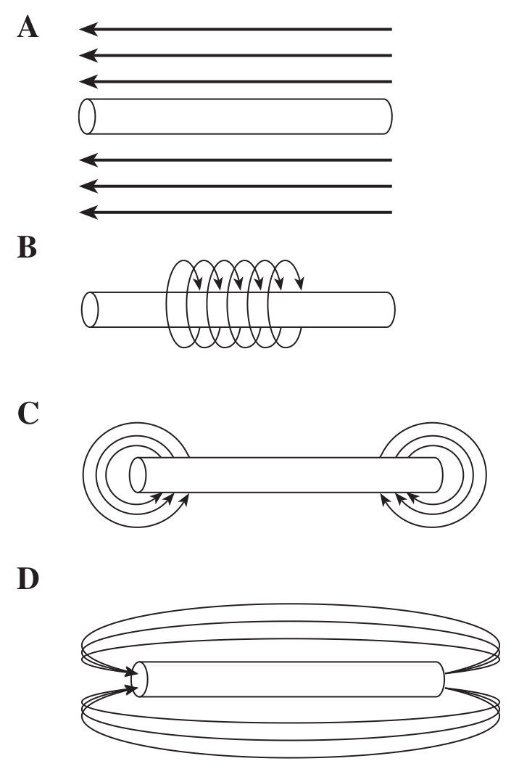
D downward.

13. The diagram below shows current flow through a wire.

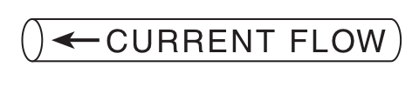

Which of the diagrams to the right represents the magnetic field resulting from the current?

14. Draw the direction of the magnetic field created by each of the situations below. (The letter i represents the current carrying wire)
14. 